**The *Fluocell* User’s Guide**

# Introduction

***Fluocell*** is a software package for the analysis and visualization of fluorescence images for live cells, with applications in migration and cancer invasion. The main package contains a visualization and quantification tool for fluorescence intensity and FRET ratio images. Optional modules of diffusion analysis and polarity analysis can be obtained upon request. This package is mainly written in MATLAB. It is being developed by a group of researchers at the University of California, San Diego, and the University of Illinois, Urbana-Champaign. As developers, we are open for collaboration on using the software or developing additional features. If you find this software package of interest or useful for your work, please take the time to cite our work and write an email to tell us, since positive feedbacks are important to secure continuous support for this software package.

Citations for publication

1. Lu S et al. 2008 PLoS Computational Biology, The spatiotemporal pattern of Src activation at lipid rafts revealed by diffusion-corrected FRET imaging.
2. Lu S et al. 2011 PLoS ONE, Computational analysis of the spatiotemporal coordination of polarized PI3K and Rac1 activities in micro-patterned live cells.
3. Lu S et al. 2014 Scientific Reports, Decipher the dynamic coordination between enzymatic activity and structural modulation at focal adhesions in living cells.

Authors

Shaoying (Kathy) Lu: [kalu@ucsd.edu](mailto:kalu@ucsd.edu) . Qin Qin, Shannon Laub, Yingxiao Wang

# Download the Source Code and Imaging Data

1. Download the fluocell source code from here: <https://github.com/lu6007/fluocell>
2. Download the fluocell dataset from here: <http://wang.ucsd.edu/~kalu/fluocell_dataset/fluocell_sample.zip> , unzip, and the install it to a folder named “fluocell\_sample/” which is readable and writable by users. The relative location of the dataset README file from the fluocell root directory is: fluocell\_sample/README.txt
3. The complete workflow of fluocell can be tested by running the test functions *test\_fluocell* with the sample dataset*.*

# Visualize the ECFP/FRET Ratio Images

Refer to the “Installation and Usage” section for details on how to install fluocell. It takes about 10 minutes to perform each task below.

In the main menu of fluocell,

|  |  |
| --- | --- |
|  |  |
| ratio_image | intensity_image |

1. Select the **FRET** protocol. Also note the first channel pattern, second channel pattern, time frame pattern, intensity, FRET ratio and processing options.
2. Open the image files: File 🡪 Open Figure 🡪 Navigate to the image files 🡪 **Be sure to open the first channel file among the list of files,** and make sure that the “Time Frame Pattern” matches the string pattern in the file name. Sample data image files can be found in the folder: fluocell\_sample\ 10\_24\_08\_Src\_fret\_pax\. The first channel image file for src pax is ‘2-11.001’. Note here how the file name patterns including “First Channel Pattern”, “Second Channel Pattern”, “Time Frame Pattern”, etc. are defined in the fluocell main window. As shown to the right, the CFP/FRET ratio image will be displayed in Figure 1 and the intensity image of FRET will be displayed in Figure 2. There are options to subtract background and apply median filter.

The intensity and FRET ratio information are needed for processing the ratio image. Independently, the intensity images can be adjusted using the colormap editor by clicking the Figure 2 menu: Edit 🡪 Colormap. The figures can be copied by clicking Alt+Print Screen, or Edit 🡪 Copy Figure, and pasted to a Microsoft PowerPoint file.

1. Close files and quit the image tool: File 🡪 Close 🡪 Quit. Note: it is necessary to close the processed image using the Fluocell interface cleanly: File 🡪 Close Figure instead of closing it directly by clicking “x”.

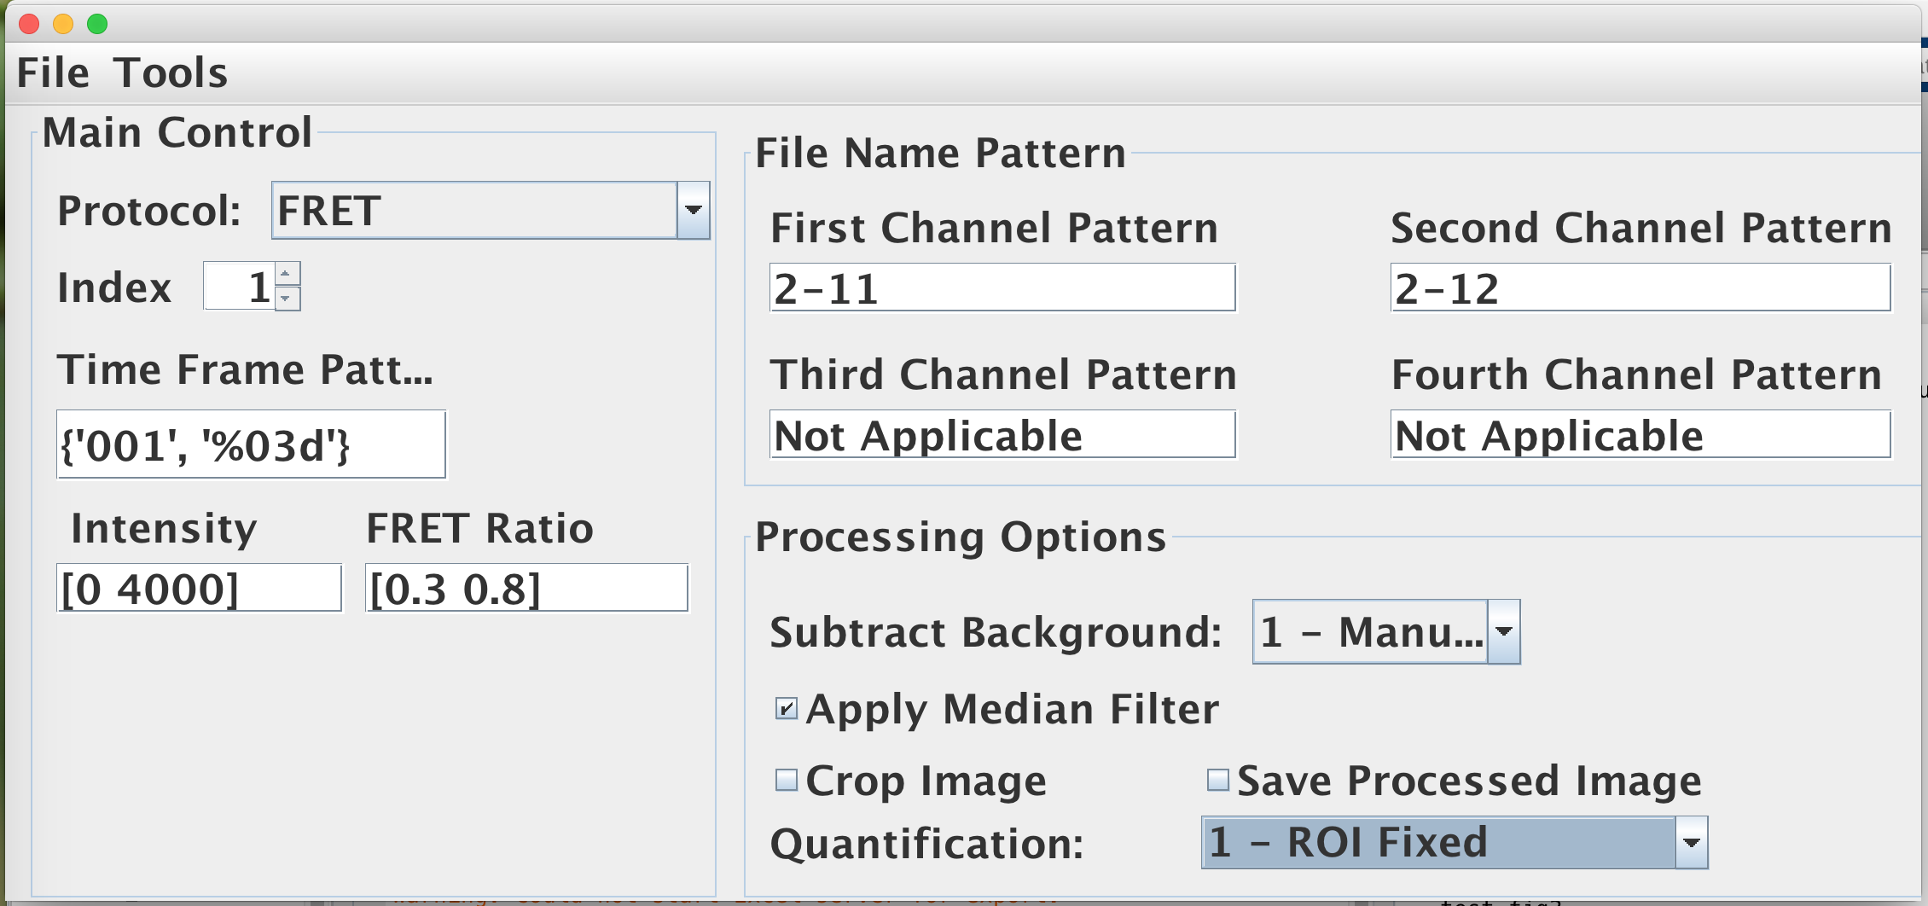

# Quantification using regions of interest (ROIs).

1. In the Fluocell Menu, there is a dropdown list that includes four different options. Select 1 – ROI Fixed.
2. Batch process: Tool 🡪 Batch Update Image 🡪 To process images from 1 to 10, set Image Index to [1:10] 🡪 click ‘OK’ **only once**.

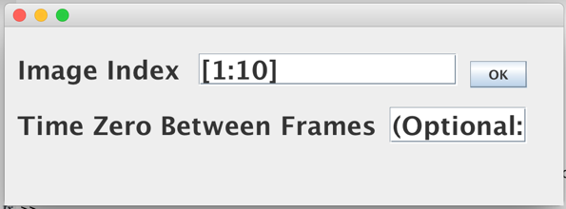

1. To retrieve data, copy the output variables from the MATLAB Workspace to Excel: fluocell\_data 🡪 time, fluocell\_data 🡪 ratio, fluocell\_data 🡪 channel1 (average intensity of the first channel); fluocell\_data 🡪 channel2 (average intensity of the second channel). The fluocell\_data.time variable has two columns. The first column contains the index number of the image frames. The second column contains the time that the image frames were saved, in minutes starting from 12:00 am.

# Make Movies

1. Choose Fluocell settings and open a figure by going to File -> Open Figure
2. Save Ratio images by checking the box “Save Processed Image”, and in Tools -> Batch Update Image, enter the range of files (e.g. [1:10]), click ok. The processed images have been saved as .tiff files in the data folder.

Note: once the FRET images are saved, the options Intensity and FRET ratio bound will become ineffective. The background, ROI and processed image files are saved in a subdirectory output/ within the image path. When the user manually changes the index, the ratio images will automatically save in the path: fluocell\_sample\10\_24\_08\_Src\_fret\_pax\output\0.3–0.8\ (the range is determined by the ‘FRET Ratio’ setting in the Fluocell interface). The ratio images are convenient for visual inspection. To remove and re-define these files, the user needs to manually remove the saved files in output/ folder and repeat the image analysis steps.

1. Once the images have been saved, run the make\_movie function in the MATLAB command window. First, modify the function fluocell/app/sample\_init\_data.m. Replace the root variable in line 4 with the location of fluocell\_sample/ folder. Then run these commands:

>> cd ../../../app

>> data = sample\_init\_data('src\_pax','make\_movie');

>> make\_movie(data);

The function make\_movie() takes pre-existing images (.tiff) and assembles them into movies. The movie file “fret.avi” can be found in the “output\” folder within the data folder. Note: this feature currently does not work with Intensity and Intensity-DIC protocols.

# Visualize the Intensity Modified FLIM Images

Load the images from the folder “data\fluocell\_sample\flim\_0505\_2014\”

|  |  |
| --- | --- |
|  | |
|  |  |

# Polarity Analysis

Rotate the cells to the horizontal position and quantify the polarity of signal. An example using the sample data:

1. Open the Image.

* Fluocell Menu 🡪 Protocol 🡪 Intensity, Time Frame Pattern:{‘001’,’%03d’}, select “Subtract Background: 1-manual”, and check the box “Apply Median Filter”. Leave the rest to default values.
* Open the image files by selecting File -> Open Figure. Navigate to the data folder fluocell\_sample\PH-Akt-GFP\_1\ -> double click the file “AKT-PH-YFP\_PDGF52.001”.

|  |  |
| --- | --- |
|  |  |

1. The cell boundary can be detected by selecting: Tools 🡪 Adjust Brightness Factor 🡪 Show Detected Boundary. Choose the Brightness Factor for cell detection.

Menu 🡪 Tool 🡪 Adjust Brightness Factor; Brightness Factor = 1.0 (suggested values are between 0.7 and 1.3), check the box “Show Detected Boundary”. Change the index value to show the boundary. Adjust the Colormap to 0-5000, Edit 🡪 Colormap 🡪 Color data min = 0 and Color data max = 5000 (for other data, adjust as needed). \*Note: The user may see different intensities of color depending on what their default Colormap is in MATLAB.

1. In the file sample\_init\_data.m, confirm that the root variable in line 4 was updated to the location of fluocell\_sample/ folder.
2. Run the polarity quantification scripts. First change your current working directory to the Fluocell app folder. If you installed Fluocell under the folder “fluocell/”, do this:

>> cd fluocell/app

>> cell\_name = 'akt\_1';

>> data = sample\_init\_data('akt\_1');

>> single\_cell\_analyzer('akt\_1',data);

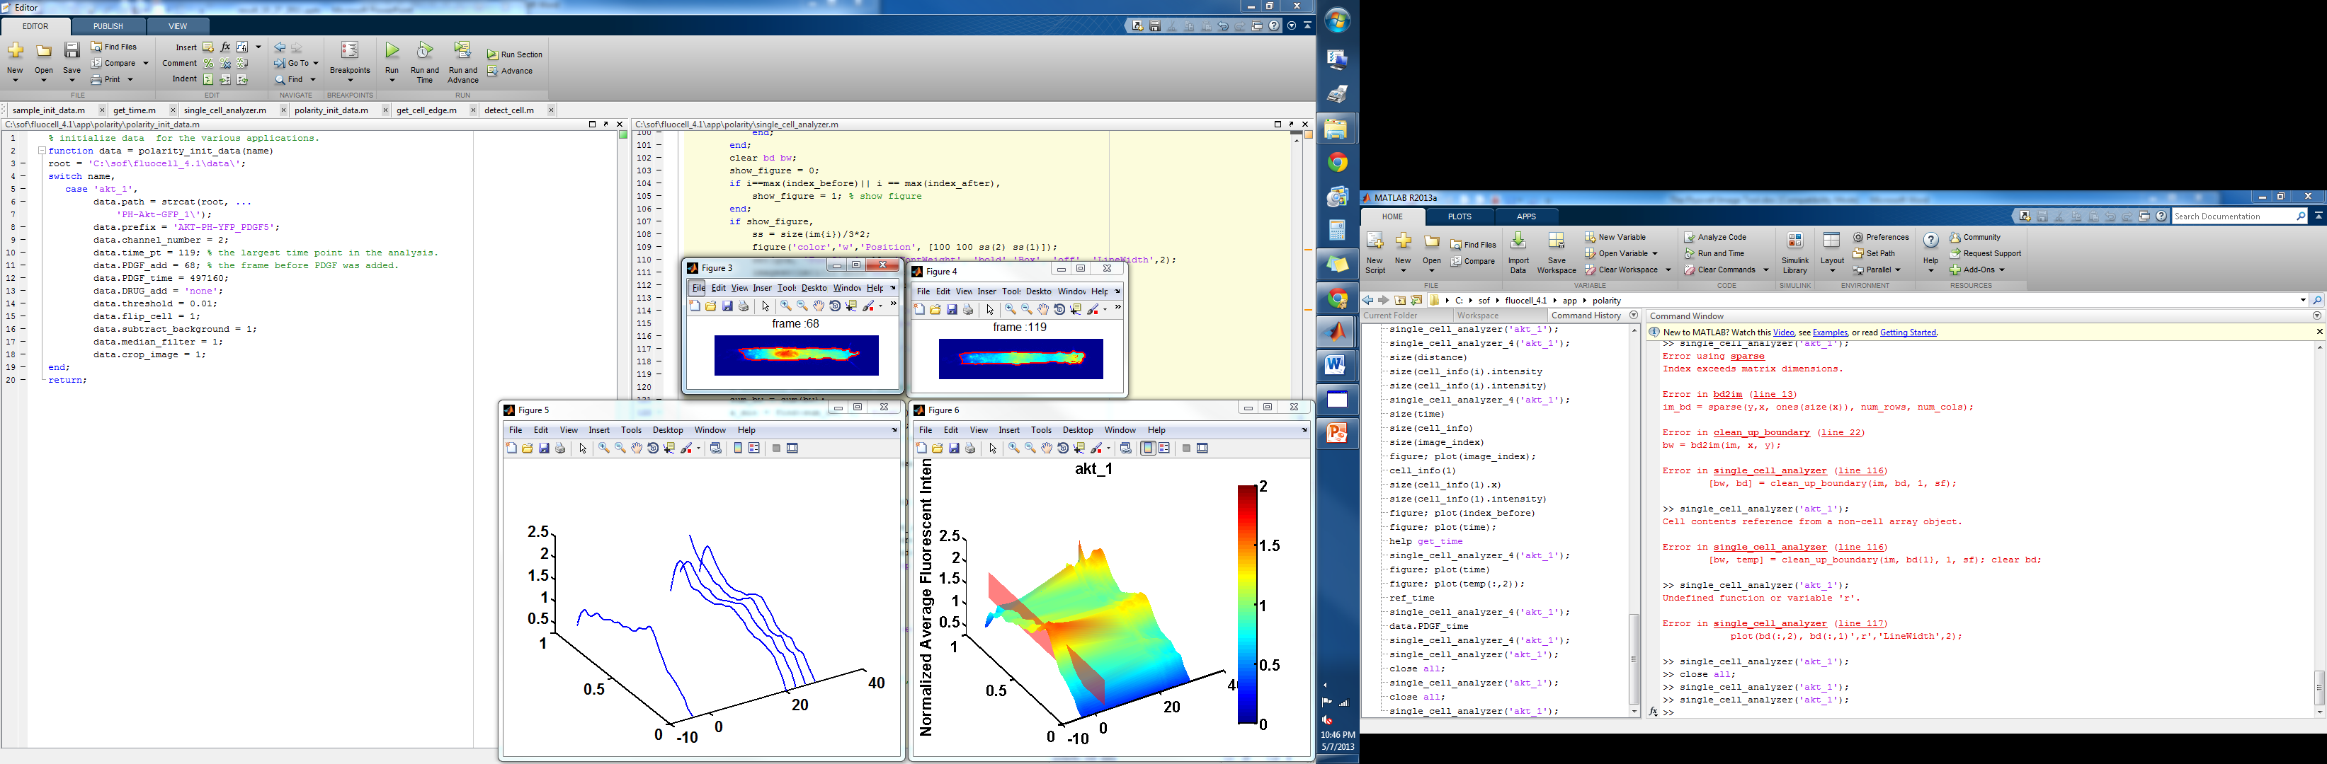

# Tracking Cells and Regions of Interest

In the “Quantification” submenu, there are four options: (1) 0 – None: no quantification on region of interest; (2) 1 – ROI Fixed: quantify the region of interest without tracking cell; (3) 2 – ROI Track Cell: quantify the region of interest while tracking the cell.

**Note** that the option to “Apply Mask” may create a conflict if Fluocell detects another cell in the mask and moves the ROIs by mistake. To avoid this conflict, close the figures and re-open the figures each time when the “Apply Mask” is checked or unchecked.

For the next example, use the Fluocell GUI to navigate to another example data: tracking\_ex/ folder. The values and options of brightness factor, number of ROIs etc are chosen in the menu “Tools 🡪 Adjust Brightness Factor”.

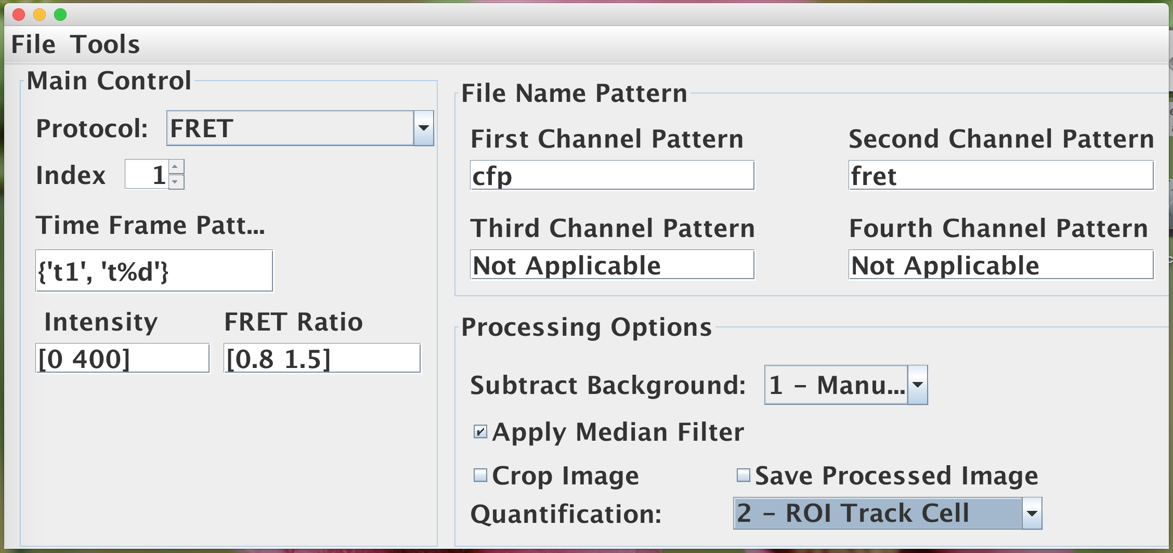

|  |
| --- |
|  |
|  |

To quantify subcellular layers, choose “3 – Quantify Subcell”. In this case, the default number of layers is 1, and the user can change it by setting “Number of ROIs” to 1 in the “Adjust Brightness Factor” menu.



Alternatively, if “Number of ROIs” is set to 3, we have



The quantification output can be found in the MATLAB workspace, under the variable “fluocell\_data”, such as fluocell\_data.time, fluocell\_data.ratio, fluocell\_data.channel1, fluocell\_data.channel2 etc. The average ratio or intensity values in the ROIs will be calculated and updated in fluocell\_data. When multiple subcelluar regions are marked, each ROI is the region between two curves, numbered from outside in as labeled in the picture above. When z\_stack is enabled, time-course quantification is disabled, and quantified z\_stack values are stored in the vector.

# FA Detection and Subcellular Quantification

1. Detect cell mask. The following commands will detect a sequence of cell masks and output mask files to the subfolder output/

>> cd fluocell/app/fa\_analysis/

>> cell\_name = 'src\_pax';

>> data = sample\_init\_data(cell\_name, 'batch\_detect\_cell');

>> batch\_detect\_cell(cell\_name, data);

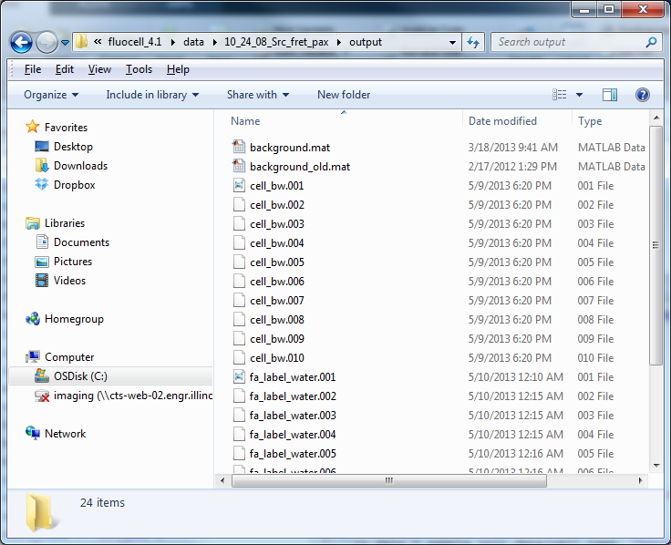

1. Detect Focal Adhesions

>> cell\_name = 'src\_pax';

>> data = sample\_init\_data(cell\_name, 'batch\_detect\_fa');

>> batch\_detect\_fa(cell\_name, data);



1. Programs to quantify local FRET ratio and FA intensity.

>> compute\_fa\_property(cell\_name, data);

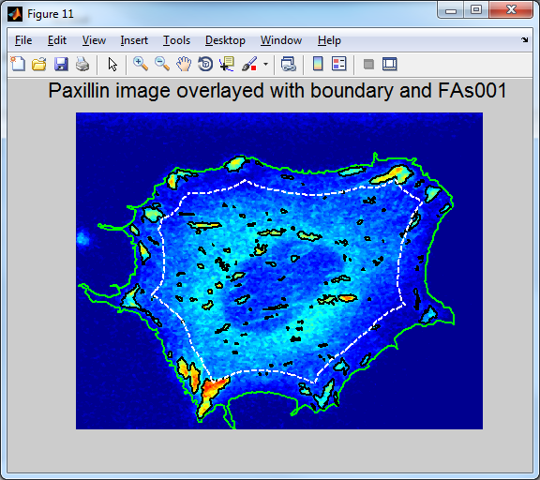

# Useful Fluocell Functions

It is required that the image sequence of each cell is located in a separated folder. This function can be used to divide multiple position data into different folders: batch\_sort\_file\_multiple\_position(path, sub\_dir). Note: please don’t name a file with any space, which may confuse MATLAB programs.

1. Example:

>> path = 'E:\sof\fluocell\_2.1\data\migration\07\_01\_2010\';

>> sub\_dir = {'FN5\2\_2\', 'FN5\2\_3\', 'FN5\2\_FBS10\', 'FN10\1\', 'FN20\1\'};

>> batch\_sort\_file\_multiple\_position (path, sub\_dir)

1. The *test\_fluocell* m-file can be run to test the general functionality of Fluocell on your computer. The location of data file on your local computer needs to be set for the “*root*” variable in the “*sample\_init\_data()*” function.
2. Different types of regions of interest. By default, fluocell allows the user to choose a region of polygonal shape which is supplied by the user. There is an additional option to choose a circular region of a fixed diameter. This can be set up in MATLAB by

>> fluocell\_data.roi\_type = ‘circle with fixed diameter’;

>> fluocell\_data.roi\_diameter = 100;

If you want to switch back to a polygonal region, simply remove the roi.mat file from the output/ folder and set:

>> fluocell\_data.roi\_type = ‘any’;

>> fluocell\_data.roi\_diameter = 0;

# Frequently Asked Questions

1. *How are the channel patterns and time frame pattern for the images obtained using software other than metamorph.*

*Answer:* The channel patterns and time frame pattern are provided by the user to help Fluocell to recognize the donor and acceptor image files. The default values will work for the image files obtained from out Nikon microscope via metamorph. For example, the image files have the names such as fret11.001, fret11.002, …, fret12.001, fret12.002 etc.

The first channel pattern: fret11 ; the second channel pattern: fret12; the time frame pattern: {‘001’, ‘%03d’}, where the pattern string ‘%03d’ follows the convention in C++ or MATLAB, meaning an integer of 3 digits padded by 0. And the string ‘001’ should match the first donor image file that you click when opening the image. In another example, the image files have the names such as cfp\_t1.tiff, cfp\_t2.tiff, …, yfp\_t1, yfp\_t2 etc.. The first channel pattern: cfp; the second channel pattern: yfp; the time frame pattern:{‘t01’, ‘t%d’}, where ‘t%d’ means the letter ‘t’ followed by an integer.

1. *The first images opened correctly, but Fluocell cannot navigate through the time sequence.*

*Answer:* The Fluocell software uses the “time frame pattern” submitted by the user to recognize file names and navigate through the time frame. For example, if the first image file has the pattern filename\_t1.TIF, the software will replace ‘t1’ with ‘t2’, ‘t3’, ‘t4’ etc. But, if thr image has the file name pattern fret18\_t1.TIF, Fluocell will process the next file in the time sequence as fret28\_t2.TIF by replacing the ‘t1’ in two places in the file name. In order to fix this problem, the file name pattern needs to be defined as {‘\_t1’, ‘\_t%d’}, so that Fluocell can correctly replace the unique pattern ‘\_t1’ with ‘\_t2’, ‘\_t3’, ‘\_t4’ etc.

Note: Moving the Fluocell folder between operating systems may cause problems to arise. If Fluocell needs to be run on multiple systems, it is recommended that each system download its own copy of the Fluocell program.

# Installation and Usage

Download and install Fluocell either in the folder C:/Program Files/ or a local user folder. It takes about 30 minutes to install Fluocell on an average computer.

Installation check list (3 steps):

1. Connect MATLAB with Fluocell installation. In MATLAB, add Fluocell programs to the searching path by clicking Set Path 🡪 Add with Subfolder 🡪 double click the files to add 🡪 fluocell/app/ and fluocell/src/ 🡪 Save . The resulting pathdef.m file should be saved either to its default location (MATLAB/toolbox/local/) or the same directory as “fluocellJava.jar” (usually in fluocell/src/gui/java/). After the searching path is properly added, the unit test function *test\_fluocell()* should run with no problem.
2. Update Java on your computer. In the folder fluocell/src/gui/java/ , double-click to run the “fluocellJava.jar” file. If Java is properly updated, the fluocell menu (below-left) should launch. For the new version of Java 14 and 15 with mac os, fluocellJava.jar cannot run by double-clicking. Instead, in the folder, run fluocell by using the command

$ java -jar fluocellJava.jar

|  |  |
| --- | --- |
|  |  |

1. Connect *Fluocell* with MATLAB installation. (1) In the fluocell/src/gui/java/ folder, make a copy from “win-default.property” (“mac-default.property” on Mac) to “default.property”; (2) Open the “default.property” file with a text editor, and after “matlablocation=” enter the path to MATLAB executable. If *Fluocell* is correctly connected with MATLAB installation, a MATLAB command window (above-right) should launch after running “fluocellJava.jar”.

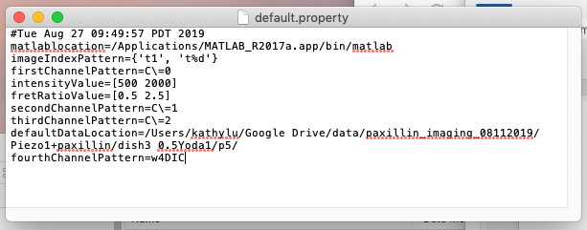

On Mac computers, a sample default.property file is shown at right.

In Windows, use double backslashes(\\) between directories, since a single backslash is the escape key (e.g. “matlablocation=C\:\\Program Files\\MATLAB\\2013a\\bin\\matlab.exe”).

To Open Fluocell:

* On Windows/Mac
  + Double click “fluocellJava.jar”. The fluocell menu and a new session of MATLAB should launch. If the fluocell menu does not launch, please update your java installation. If the MATLAB window does not launch, then the installation of MATLAB needs to be input into fluocell by editing the “default.property” file.
  + For future convenient usage, please make a shortcut of the executable file “fluocellJava.jar” and move it to the desktop. Do not make a copy of “fluocellJava.jar” since the java file needs to be in the same folder as the “default.property” file.

* On Linux
  + In the terminal, navigate to the directory containing “fluocellJava.jar.”
  + Enter “sudo java –jar fluocellJava.jar.” A window should appear, and a new session of MATLAB should launch.

# Updates

1. Version fluocell-6.0